- Before updating the TANF Time Limits Months, re-open the TANF program block using Re-apply for a new application or Rescind as appropriate.
- Navigate to the Time Limit Summary page.
- Click the Name hyperlink for the consumer in the Cash-Aid block.
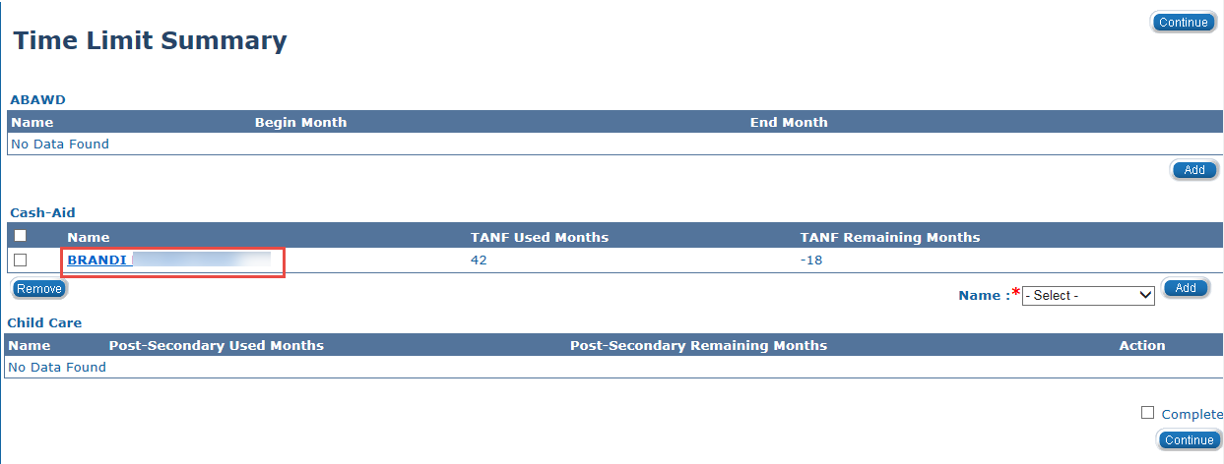
- The Cash Aid Time Limit Month List page displays. Use the snipping tool to screenshot the Cash Aid Time Limit List page(s) and image the screenshot(s) to the Journaling document type in ImageNow.
- From the Cash Aid Time Limit Month List page, click the Checkbox associated to the month(s) you want to remove to get the TANF Months Used field down to 22 months. Best practice is to first remove the most recent TANF months received in Kansas.
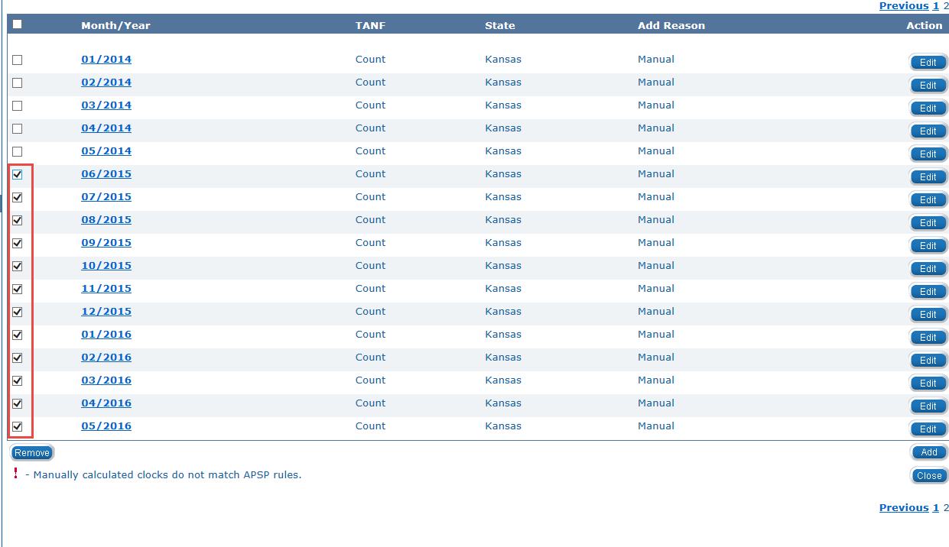

- Click the Remove button.
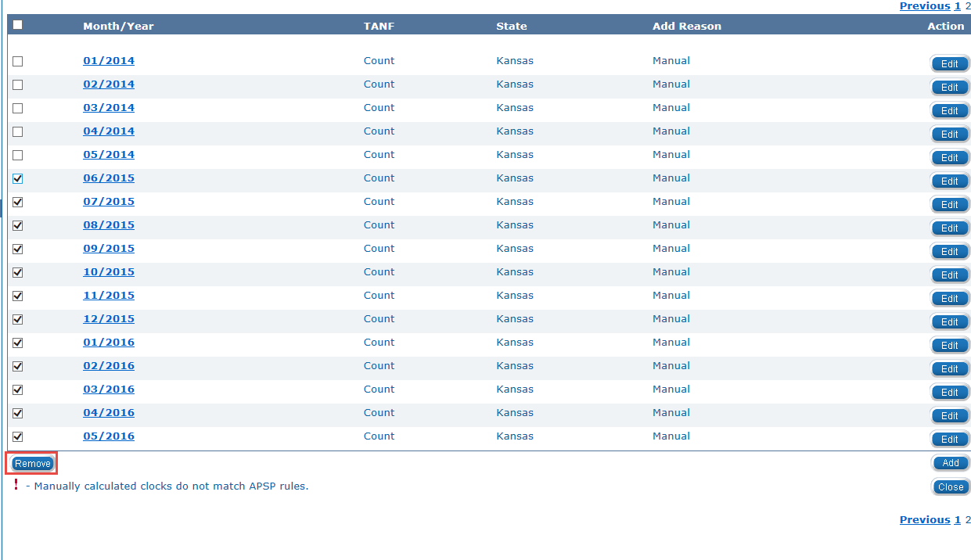
- Process the Application and Run EDBC through the Come Up Month.
- Navigate to the Time Limit Summary page.
- Click the Name hyperlink for the consumer in the Cash-Aid block.
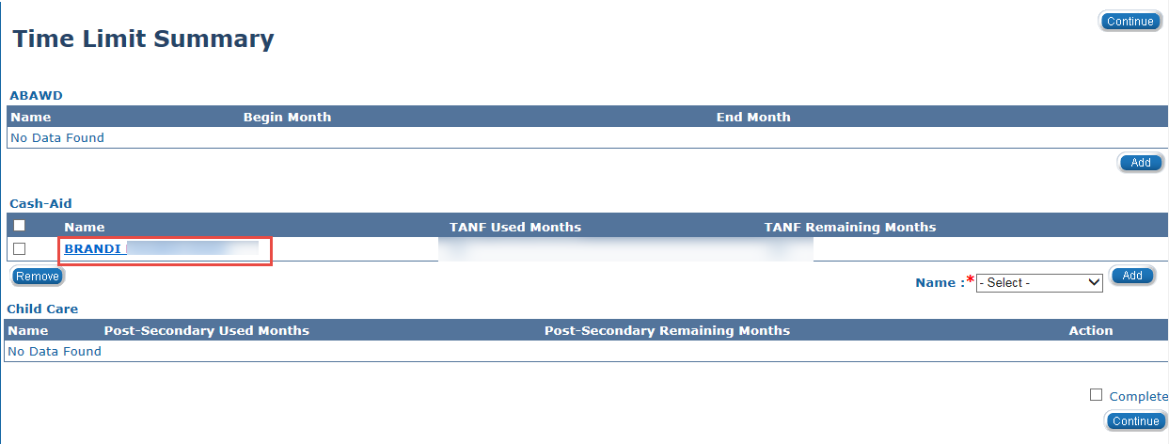

- The Cash Aid Time Limit Month List page displays. Click the Add button.
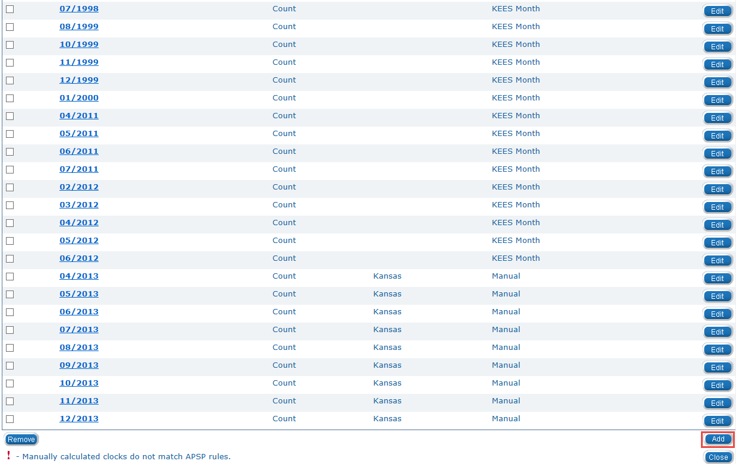
- Enter the Begin Month and End Month using the <mm/yyyy> format or the calendar icon. Remember to add the exact months previously removed.

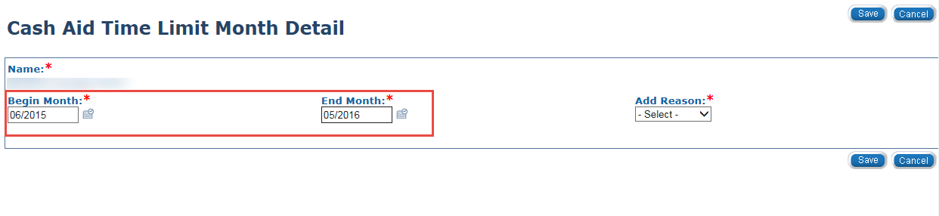

- Select Manual from the Add Reason drop-down menu. Additional fields dynamically display.
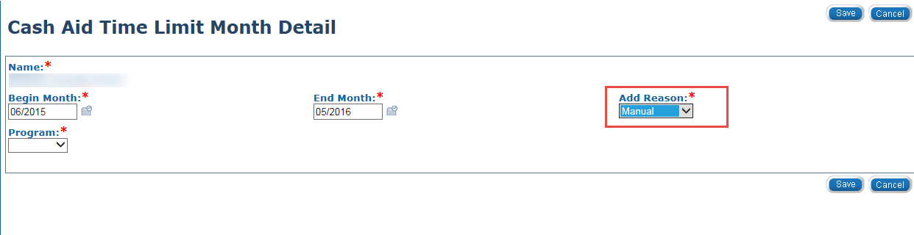
- Select TANF from the Program drop-down menu.
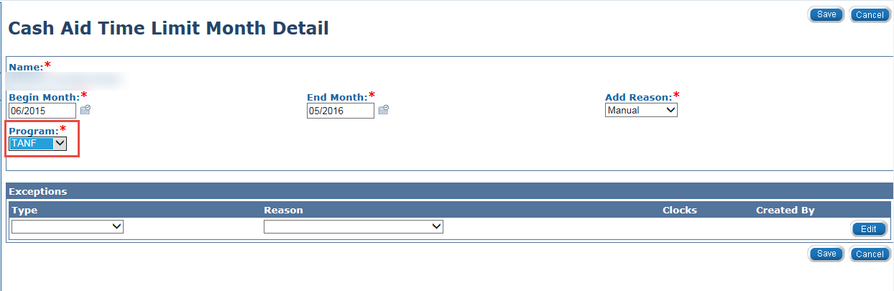
- Select Hardship from the Type drop-down menu.
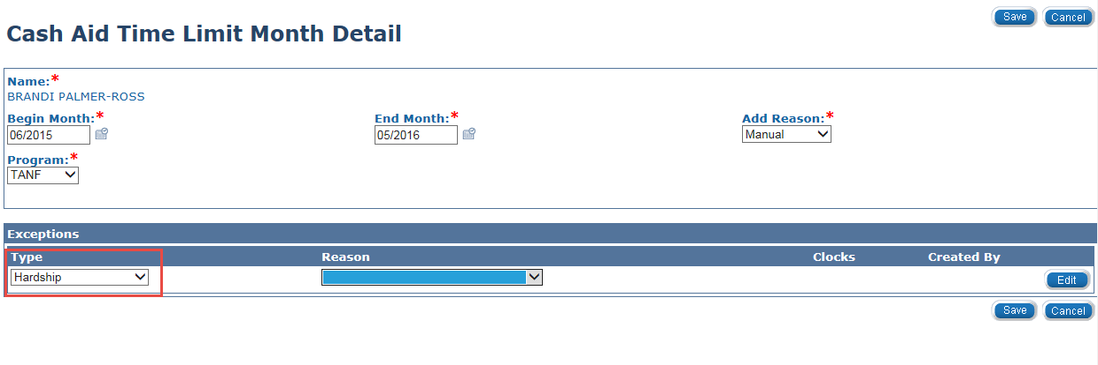

- Select the appropriate Hardship Reason from the Reason drop-down menu.
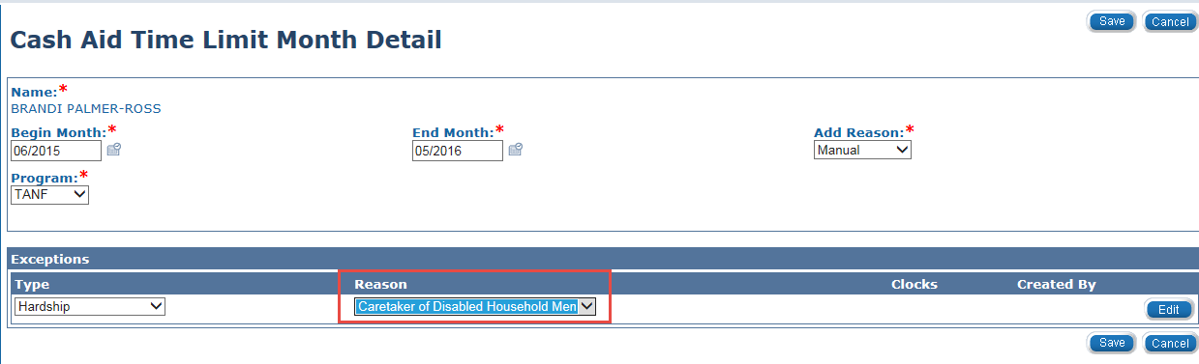
- Click the Save button. The Cash Aid Time Limit Month List page displays.
